|  |  |
| --- | --- |
| find your Group  Final Project Report | Abstract [Draw your reader in with an engaging abstract. It is typically a short summary of the document. When you’re ready to add your content, just click here and start typing.]  Fangning He, Fei Li, Yunlu Zhou, Zhiyi Wang  INFO6150 38687 Web Design/User Experience Engr SEC 04 - Spring 2017 |

Contents

Topic of the project: 2

Introduction 2

Problem definition 2

Scope 2

Data flow 3

Configuration 3

Technologies: 3

Project Detail Introduction 3

Register 3

Login 3

User Home 3

User Personal Page 3

Friend Page 3

Photo Wall: 3

## Topic of the project:

## Introduction

This project is a social media website, on which people can build and join friends’ circles where they belong to. Features like pointed posting and timeline story can be used to enhance people’s commitment to their circles and provide a strong notion of community. Ultimate goal of this website

is to practice our web developing skills and dig our own potential to achieve a practical social need.

## Problem definition

Using frond end technique to build a social media website, providing an approach for people to share ideas, exchange cultures and connect with others.

## Scope

* + In scope:
* Register/Login/Logout
* Create profile
* Search a friend/ a circle
* Add/Remove a friend
* Post/delete/comment
  + Out of scope:
* Timeline/Event photo film/animation
* Initiate/Join events/group message
* Tag members on post/link tag to other’s homepage
* Detail of the upcoming events (direction, add to calendar)
* Recommend friends or events

## Data flow

## Configuration

## Technologies:

**Front-end:** HTML5，CSS3, Bootstrap, JavaScript, JQuery

**Back-end**: PHP, SQL

## Project Detail Introduction

### Register

### Login

### User Home

### User Personal Page

### Friend Page

### Photo Wall:

In Photo Wall page, a jQuery plugin named masonry is implemented to create a Pinterest layout.

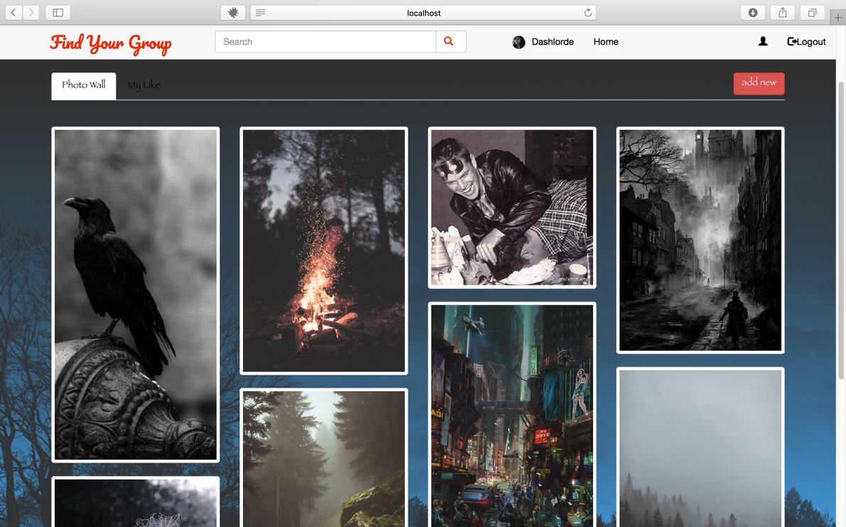

User can upload photo directly in Photo Wall, focus on one of the pictures and delete picture.

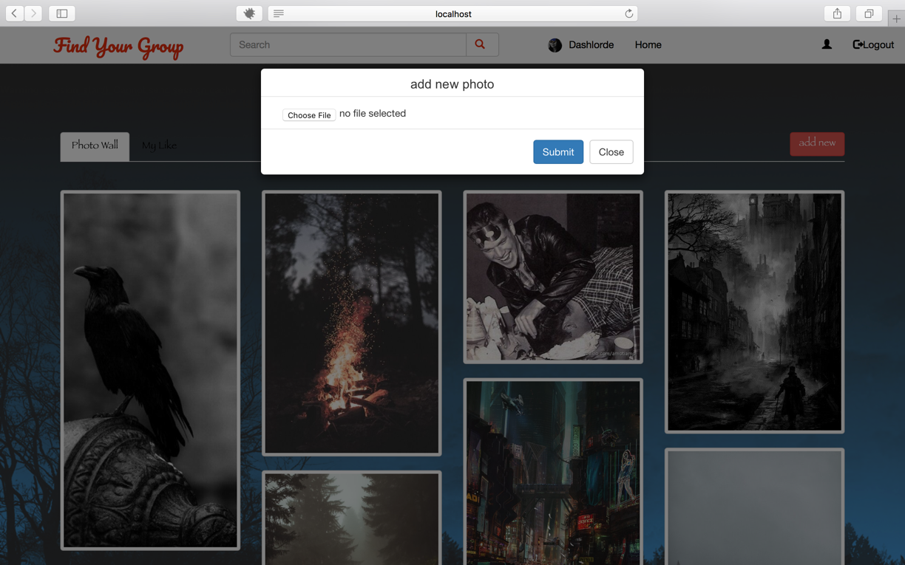

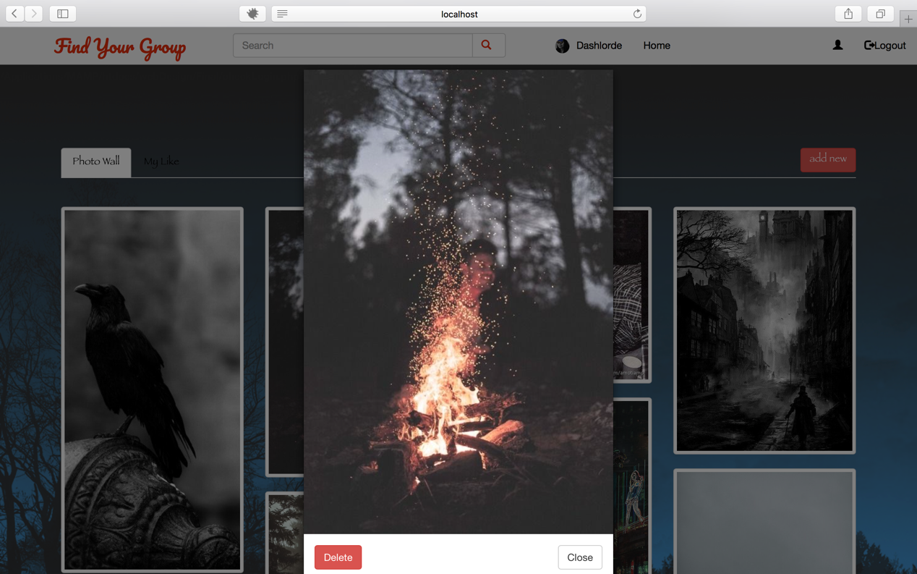

Moreover, user can add photo to like list, and all liked photo will be displayed in My Like tab content. The color of heart icon will change if user add the picture to like list.

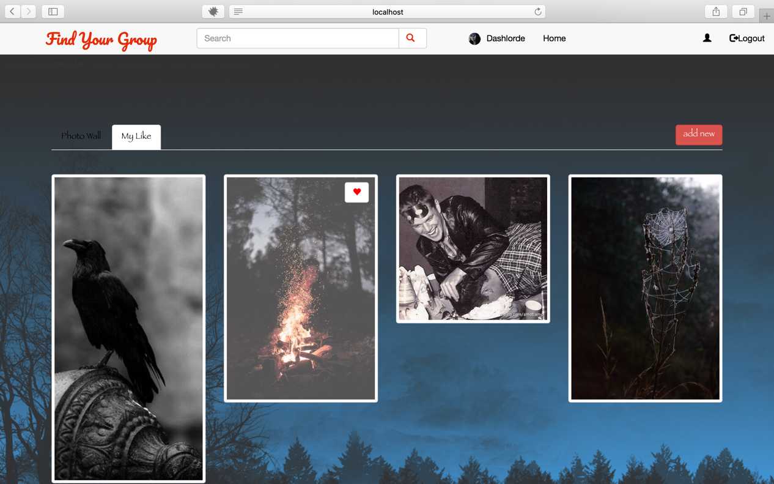

### Profile:

In profile page, a JQuery validation plugin is implemented to validate user’s input. If user input wrong format, error message will be shown immediately. In addition, PHP validation is also configured a more security environment.

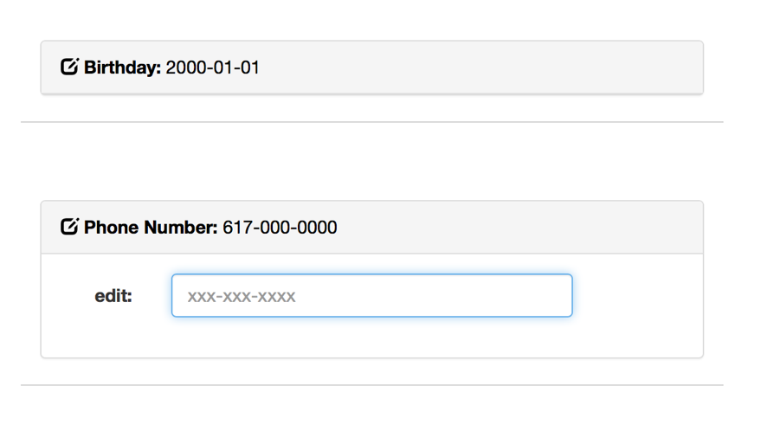

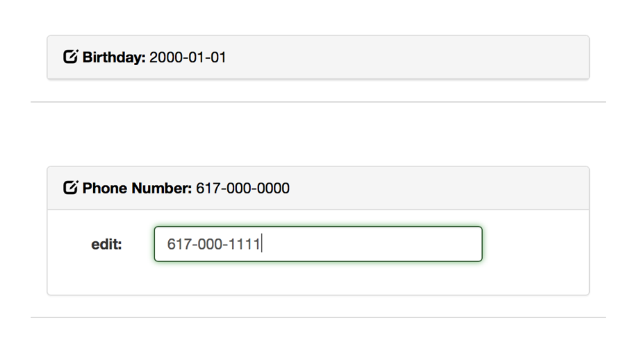

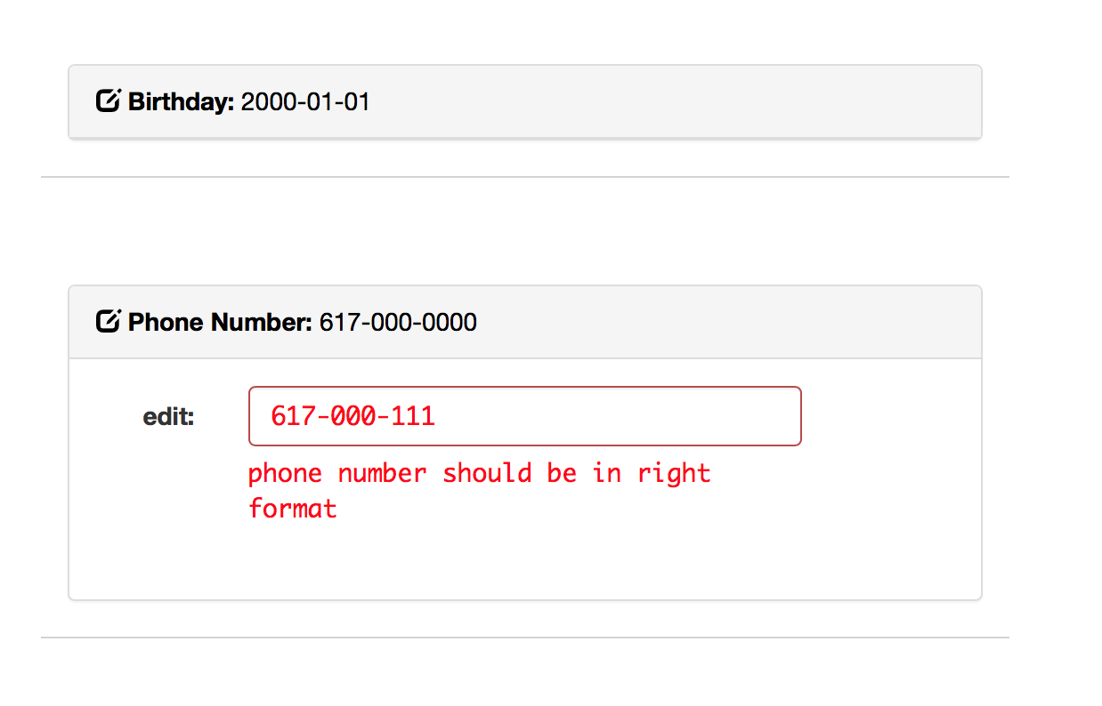

### Database and picture stored configuration

To conveniently synchronized database and pictures in team work. We use Amazon Web Services to create remote database and a bucket for user picture storage. Therefore, this project cannot run directly. Some files need to edit in order to run with local database and local picture storage, or RDS and S3.

The configuration detail is written in readme file in the project root folder.